Name: Shaunak Deshpande

Branch: Instrumentation and Control Engineering

Year: TY

Division: C

Batch: 2

Roll Number: 39

Gr Number: 11911180

Lab Assignment 1

Date: 18-08-2020

**Control Theory Lab 1 dated 06-09-2021.**

**Python Code:**

import numpy as np

import control

from matplotlib import pyplot as plt

a0=3

a1=4

b0=1

b1=2

num = np.array([b1, b0])

den = np.array([a1, a0])

H = control.tf(num, den)

# %% Displaying the transfer function :

print ('H ( s ) = ', H)

#For RC Circuit with Capacitance of 1 mF and resistance of 100k Ohm

num=[1]

den=[100,1]

print('H(s)=', control.tf(num,den))

**Output:**

1. H ( s ) =

2 s + 1

-------

4 s + 3

1. H(s)=

1

---------

100 s + 1

**Coursework:**

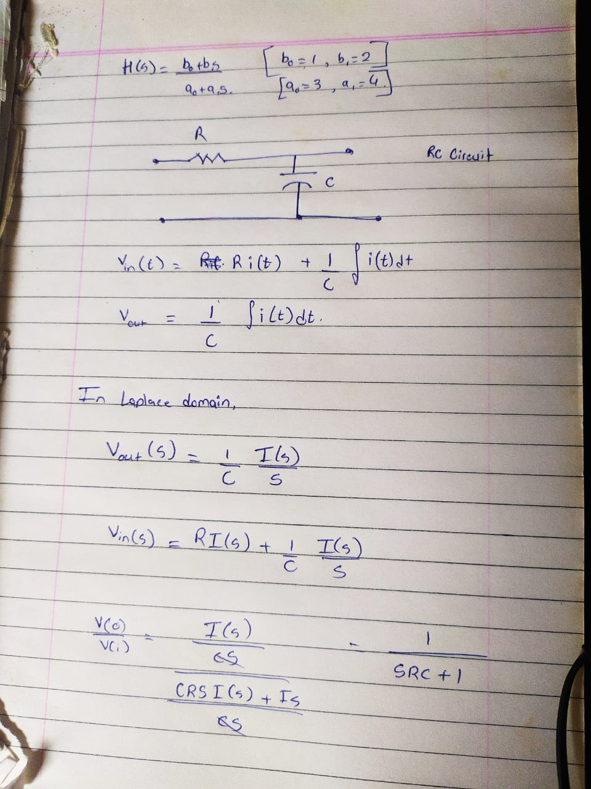

**Learning outcomes:**

1. Using Control Library in Python
2. Tf module in control library
3. Transfer function of an RC Circuit

**Conclusion:**

We learned the concept of transfer functions and how to plot their graphs for circuits like RC circuits etc, & understood the concept of transfer functions.